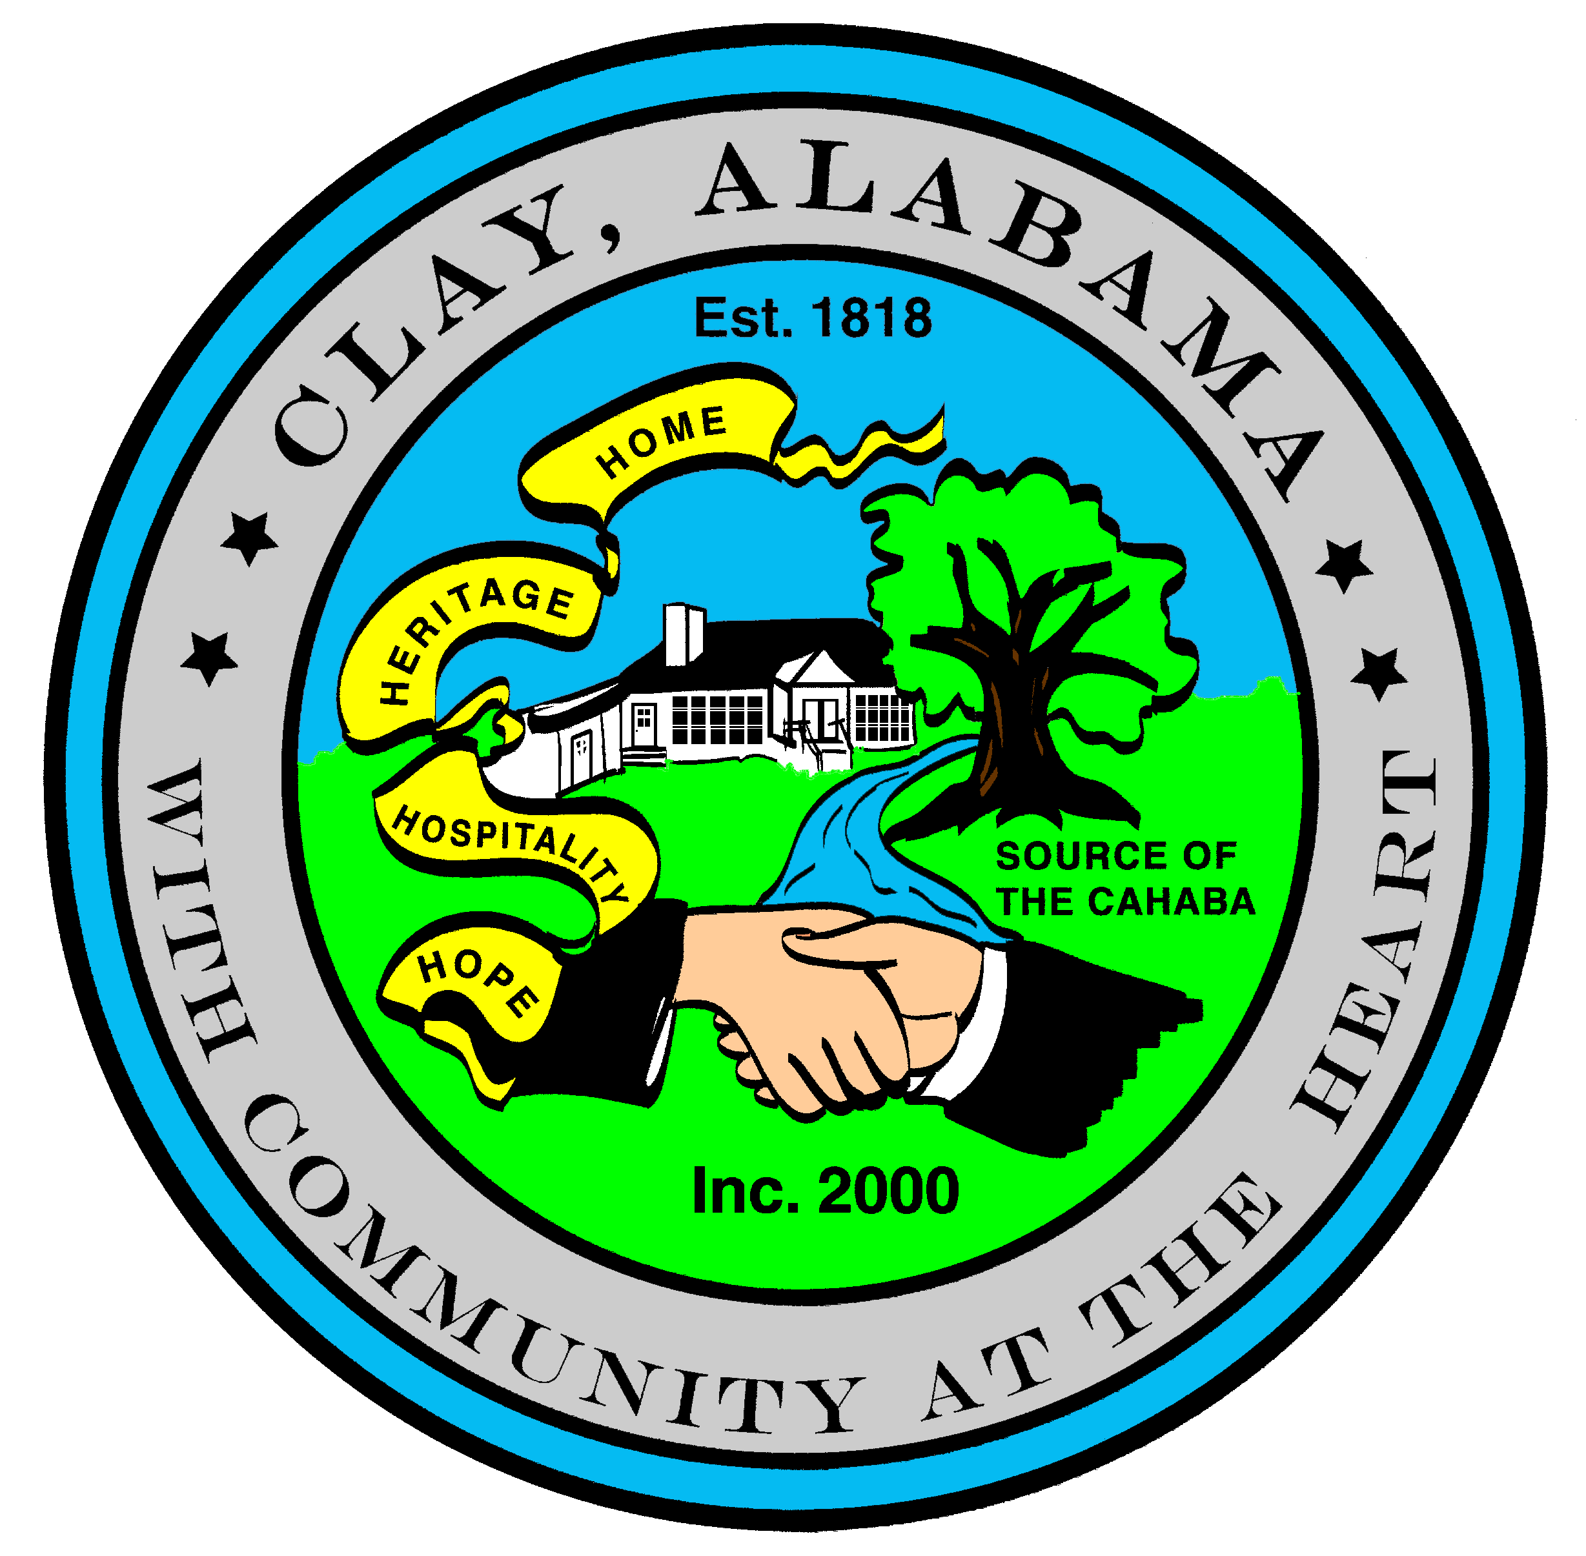
Resolution 2023-14
STATE OF ALABAMA
JEFFERSON COUNTY
CITY OF CLAY

A Resolution Authorizing the Elimination of
a Nuisance Upon Private Property

WHEREAS, the City Council of the City of Clay, Alabama adopted Ordinance 2010 – 03 on the 15th Day of February, 2010; and

WHEREAS, said Ordinance was adopted to control and abate the nuisance created by overgrown grass and weeds within the City Limits of Clay, Alabama that may be injurious to the general public health, safety and general welfare by providing breeding grounds and shelter for rats, mice, snakes, mosquitoes, and other vermin, insects, and pests or attaining heights and dryness that constitute a serious fire threat or hazard; or bearing wingy or downy seeds, when mature, that cause the spread of weeds, and when breathed, irritation to the throat, lungs, and eyes of the public; or hiding debris, such as broken glass or metal, that could inflict injury on a person going upon the property; or being unsightly; or growth of grass or weeds, other than ornamental plant growth, that exceeds twelve (12) inches in height; and

WHEREAS, the City Council adopted Resolution 2023-12 on the 13th Day of June, 2023, declaring the following property to be a public nuisance:
5209 Baggett Drive PID = 12-00-09-1-000-017.000
5542 Spanish Trace PID = 12-00-04-4-002-002.045
5732 Shadow Lake Drive PID = 09-00-34-3-001-007.000
6455 Kathy Drive PID = 09-00-34-1-000-029.000
6467 Kathy Drive PID = 09-00-34-1-000-122.000

NOW THEREFORE BE IT RESOLVED, that all requirements of Ordinance 2010-03 have been satisfied for giving notice to the property owners and giving notice for a Public Hearing; and

NOW THEREFORE BE IT FURTHER RESOLVED, that the City Council, by adoption of this Resolution, authorizes the City and/or its duly authorized agents, private contractors, companies, enterprises, or individuals to abate and remove the current nuisance.

ADOPTED AND APPROVED, this 11th Day of July, 2023.

__________________________________ Attest: ____________________________
Charles K. Webster Ronnie Dixon
Mayor City Manager

Resolution 2023-14

I, the undersigned City Manager of the City of Clay, Alabama, do hereby certify that the above and foregoing is a true copy of one Resolution lawfully passed and adopted by the City Council named therein, at a regular meeting of such Council, and that such resolution is on file in the City Clerk’s Office.

I further certify that said Resolution was posted as required by State Law at the following locations: Clay City Hall; Clay Post Office; Clay Seniors Center; and the Clay Public Library all being in the City of Clay.

IN WITNESS WHEREOF, I have hereunto set my hand and affixed the official seal of the City on this 11th Day of July, 2023.

______________________________________
Ronnie Dixon
City Manager

